
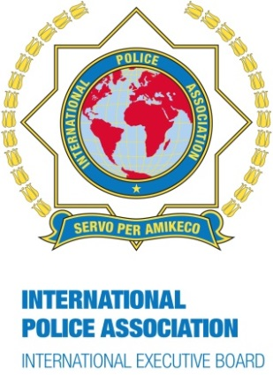
IPA Newsletter
February 2017
International Administration Centre
Arthur Troop House
1 Fox Road, West Bridgford
Nottingham, NG2 6AJ
England

Tel: + 44 115 945 5985
Email: iac@ieb-ipa.org
Net: www.ipa-iac.org

Flying the flag for IPA at any time of the year!

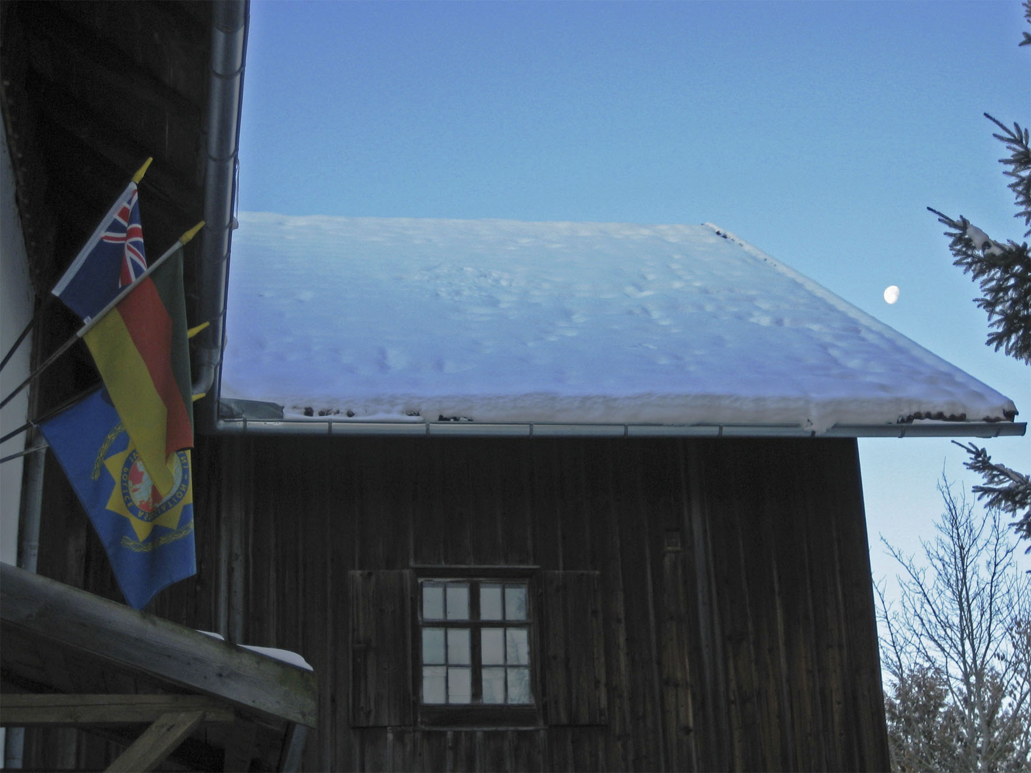

A beautiful winter photo from our photo competition 2014

WORD OF INTRODUCTION

What a gift!

Today, I received my IPA membership card 2017 in the mail, together with a nice letter from the secretary general of my section. In addition to the gratitude I feel for the great administrative work put in to deliver it, what a “treat” and pleasant moment!
A simple card, nothing fancy, but what a meaning behind it.
It recognises me as a member of the International Police Association, the same as nearly 420’000 other members around the world, without distinction to rank/position, gender, race, language or religion, as quoted in our international statutes.
Find me another organisation with such equality, gathering members from all over the world who all receive the same card! This little piece of paper really means the world and is the best passport you can dream of, a guarantee that all bearers have the same understanding and belief in Human Rights, peace and friendship. A wonderful feeling!
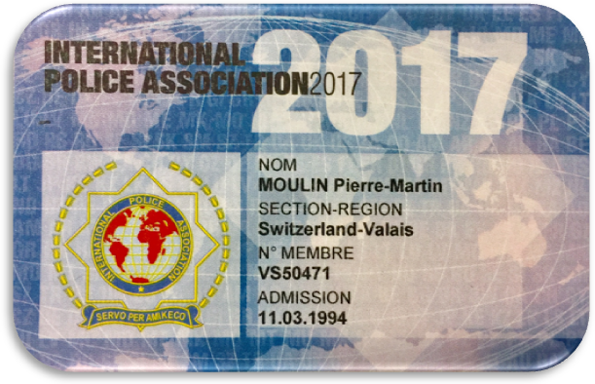
I know that some of you are not happy with the colour, the content, the form, the location of the logo, the writing, the back of the card, the absence of a photo, the printing, the material, etc … And I also know that this topic has been on the table since the very beginning of the IPA, and that throughout the decades, people keep on complaining.

But guess what? I for my part see no problems in this respect, especially when I consider that I might show this card two or at a maximum three times a year. I am extremely happy to own this card and be able to share the honour of IPA membership and all the values attached to it with so many of you in the world.

Long live IPA.

Servo per Amikeco,

Pierre-Martin Moulin, IPA President

AROUND THE WORLD

Abdullah Ahmad from IPA Pakistan reflects on the benefits
of his Arthur Troop Scholarship award 2016

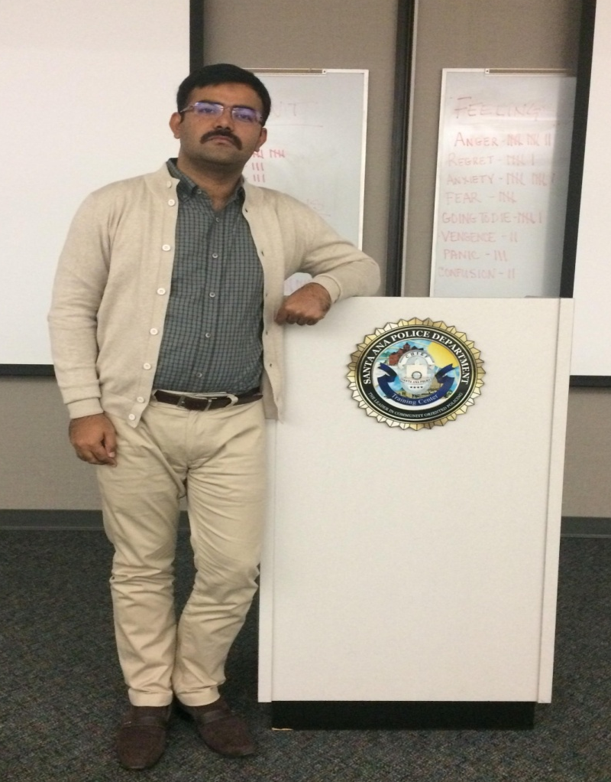
I have been a member of IPA Pakistan since December 2012 and was lucky enough to gain an Arthur Troop Scholarship for the year 2016. It is indeed a matter of great pride for me. I opted for a course on ‘Force Encounters Analysis’ at the California Training Institute, USA.
I registered to attend the course in December 2016 and left from Sukkur, Sindh, on 28 November 2016 for Islamabad to take a flight to Los Angeles, USA. It was a long journey of 15,000 kilometres, and it took me 36 hours to reach Los Angeles. The weather was pleasant, and I felt refreshed when I landed at the airport. After a sound sleep, I visited different places in Los Angeles the next day: Hollywood, the Griffith Observatory, Universal Studios, Santa Barbara and Venice beach were all places worth seeing.
The course on 'Force Encounters Analysis' for my Arthur Troop Scholarship was hosted by the Santa Ana Police Department, under the supervision of the California Training Institute, and I was received by a smiling and welcoming police officer Marty who accompanied me to the classroom to meet the instructor Mike Tosti and the other course participants. Altogether we were 30 participants, from police departments of different cities in California.
The introductory session was an interactive and interesting part of the class. We shared our life stories, and everyone was amazed to find that I had come from Pakistan, which is 15,000 kilometers away. I was welcomed warmly and found everyone very friendly and supportive. Mike Tostihad a wide-ranging experience of policing in the USA: He is a nationally recognised law enforcement instructor with 28-years of law enforcement experience and over 20 years of training credentials. He has experience as a narcotics and homicide detective, hostage negotiator, SWAT commander and traffic officer. Mike is also a veteran of the US Army.
In the introductory session the objectives of the course were explained, after which the first module – Error Management – began.We learnt to manage errors in critical conditions. Different scenarios were given to the class, and the instructor divided us into groups. The first day was full of class activities, including videos about police officers involved in shooting. All in all it was a good day and I enjoyed every second of training. Commander Ruben Ibarra of the Santa Ana Police Department was very kind and helpful and afterwards took me for a visit to the Santa Ana Police station where I observed the American police at work.
On the second day of the course, we learned to manage stress during critical situations. In particular the module regarding fatigue was very much relevant to my field. I learned why fatigue and working efficiency are co-related. Decision-making in critical conditions was also part of the module. We were shown videos that kept the attention of the participants. In addition, I took part in a ride in a patrol car with Sergeant Rodriguez. It was a unique experience for me to work with the American police.
The third and last day of class began with an interactive session. The fellow course participants asked me questions regarding Pakistan and the Pakistani Police. Their inquisitiveness was a source of encouragement for me. I tried to answer their questions and cleared their doubts regarding Pakistan and thePakistani Police. This was followed by modules on reaction time, the biodynamic of shooting: officer vs. suspect, reaction time and memory were taught. There were simulators and real- life situations which meant classes full of knowledge, activity and adventure.
During the lunch break we visited Santa Ana Jail. It was again a learning experience for me. I observed the differences between Pakistani and American jails. In the last session, we presented our assigned topics and answered questions.
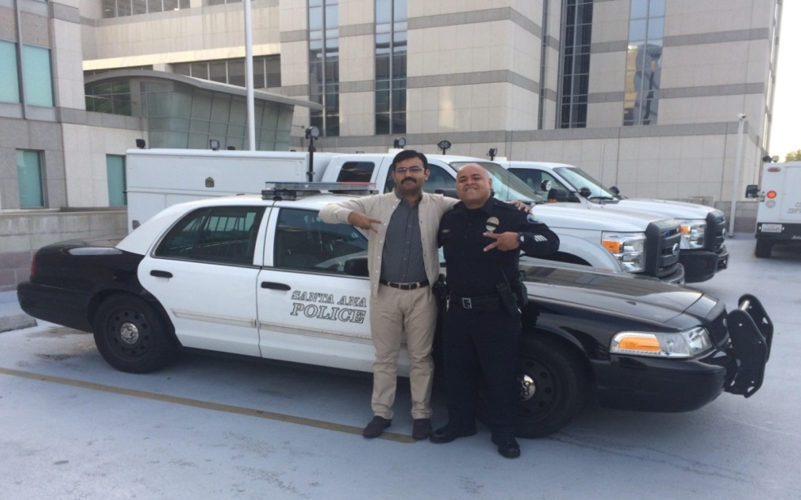
The course ended with a word of thanks from the host Santa Ana Police Department, and I was given a badge of the police department as a souvenir. I thanked the course instructor for being so kind and supportive and said good-bye to all with a heavy heart, but I was happy that I had made many friends in America. I will not forget Mike Tosti, the course instructor, Padilla, Sergeant Mel Sarabiaand Artoro Carranza of the Santa Ana Police Department, Alex Bello, instructor of the Los Angeles School and last but not the least John of the Sheriff’s Department in Santa Barbara City.
I was happy to be part of the class and have taken knowledge back to my country. I was ambitious to share my knowledge and experiences with my colleagues and subordinates. I am now able to comprehend human psychology in critical conditions. I can reduce the loss of police officers by teaching them the way to respond in force encounters situations.Although it was a long journey back to Pakistan, I was energetic and was feeling changed and enriched with new ideas and thoughts.
This training experience will go a long way in strengthening my policing career and this was only possible due to the Arthur Troop scholarship. I am highly obliged and thankful to the International Police Association and IPA Pakistan for giving me the opportunity to learn from international policing experiences. Being a police officer, who is posted in far-flung areas of Pakistan, it was a lifetime opportunity to travel abroad and learn from experiences of seasoned police officers in America. Conflict- and terrorism-hit countries like Pakistan need to learn from the world’s best practices in policing and public safety. The legacy of this training course is the lifelong friendships and a better understanding of policing systems around the world.
Abdullah Ahmad, member of IPA Pakistan
For the full report as well as other Arthur Troop Scholarship reports, please have a look on the www.ipa-iac.org website
IPA UK Youth Exchange Programme

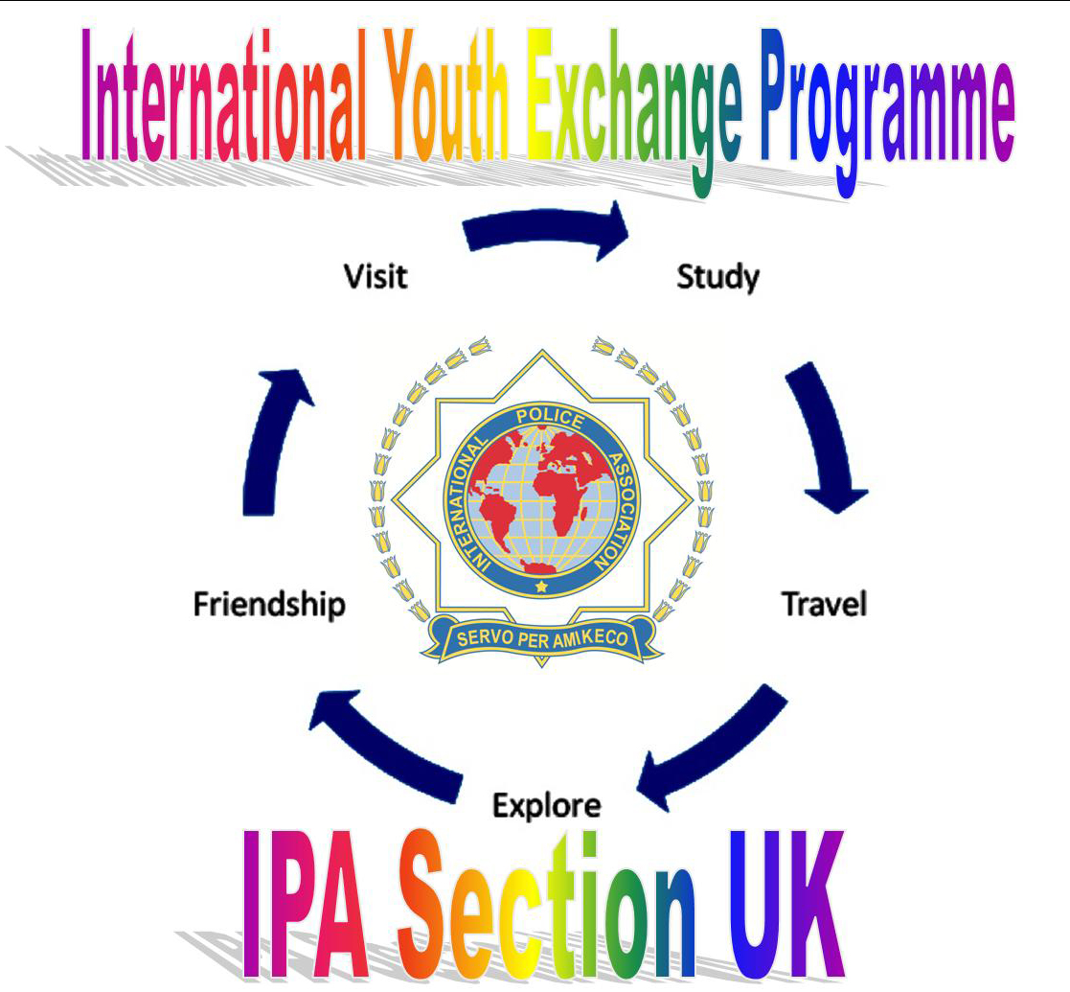
The National Executive Committee (NEC) of IPA UK are pleased to announce that Section UK has taken the decision to run its own International Youth Exchange Programme (IYEP).
The International Executive Board (IEB) coordinated an International Youth Holiday Programme for all IPA sections for many years. In recent years, however, several IPA sections became worried about legal issues relating to safeguarding of vulnerable people, including children and young adults.
The IEB initially ceased its coordination role in 2015 stating that individual sections could engage in their own arrangements for youth exchanges. Subsequently, at the World Congress 2016 the International Executive Council passed the IEB motion to cancel the Procedure for the International Youth Holiday Programme.Mick Luke, President of IPA Section UK advocated at the World Congress for retention of the programme, as did delegates from several other sections.
Section UK suspended its engagement in the programme for a period but followed through with a full review on the Section UK position. Pete Connolly, Secretary General for Section UK produced a position paper offering a range of options on how the Section might proceed. This was the subject of a lively debate by the NEC of Section UK, which voted in favour of establishing the IYEP on a formal footing.
This in turn led to the development of a new Directive for Section UK on the subject of the 'IYEP - Section UK' and an invitation from the Secretary General to all members to volunteer for the role of 'IYEP Coordinator - Section UK'. IPA UK wish to thank all those who volunteered for the post, showing support for the programme.
The volunteer chosen by the NEC is Edwin Sutton. Edwin is a serving police officer and is well known to many throughout IPA Section UK and further afield, having served previously as Secretary General of IPA UK.
Section UK has circulated its new position and guidance to all Sections of the IPA via the International Administration Centre (IAC), and all sections that will partner Section UK in reciprocal visits for children of IPA members are invited to confirm this to Section UK by email on IYEP@ipa-uk.org
Pete Connolly, Secretary General IPA UK

ON THE TABLE OF THE IEB

PROJECT BEST PRACTICE

‘Listening to their Voices of Bravery and Heroism’
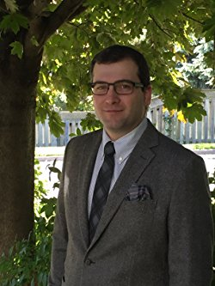
This police psychology book is the first of its kind. It illustrates case studies of police officers who have shown bravery and strength in the line of duty.
The author, Konstantinos Papazoglou, is a psychology doctoral (PhD) candidate (clinical forensics) and a Vanier Scholar at the University of Toronto, Canada. He is a former Police Captain of the Greek Police Force and the European Police College.
His book is now available at Amazon’s website:https://www.amazon.com/Listening-Their-Voices-Bravery-Heroism/

IPA members are able to benefit from a 20% discount by ordering the book via emailing the publishers at billing.central@novapublishers.com.
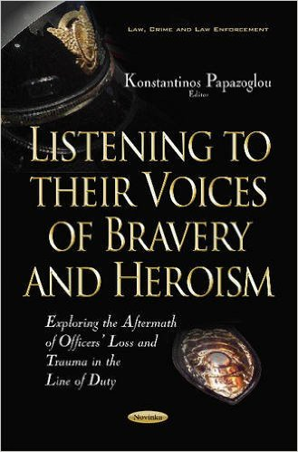
Police work is challenging. Police officers are sworn to maintain peace and order in our communities. However, police officers often jeopardize their own safety and lives in order to serve and protect civilians from imminent threat. The current book presents the testimonials of police officers who have survived from uniquely severe life-threatening cases in the line of duty, such as terrorist attacks, hostage situations, mass shootings and shooting incidents. All the cases presented in the book have been extensively covered by national and international media, amongst them CNN, NBC and CBC. The aim is to explore the impact of exposure to such unique cases in officers’ lives.
What gives officers strength during a life-threatening situation? What makes officers thwart a mass shooter or a violent criminal when civilians try to escape from the critical incident site? What helps officers survive when they are severely wounded and bleeding on the street?
The analyses of the officers-survivors’ interviews enabled law enforcement professionals, health professionals, early career researchers, and university/college students to understand strength and resilience among police officers despite exposure to extreme stress and life-threatening situations.
I encourage you to read this book.
May-Britt Rinaldo, Chair of the Professional Commission
Other IPA Accommodation

One of the strategic objectives of the IPA internationally is to establish and maintain IPA Houses for the benefit of our members. At present, we are pleased to be able to offer55 IPA Houses in 18 sections.
Due to the cost of running such facilities, IPA sections do not always find it financially viable to establish new IPA Houses.
For that reason, many sections have over the years entered into agreements with owners of privately owned facilities at which accommodation is provided to IPA members at a reduced cost – known as ‘Other IPA Accommodation’. These facilities vary from hotels, accommodation at resorts, guest houses, camping sites, private homes and apartments, etc.
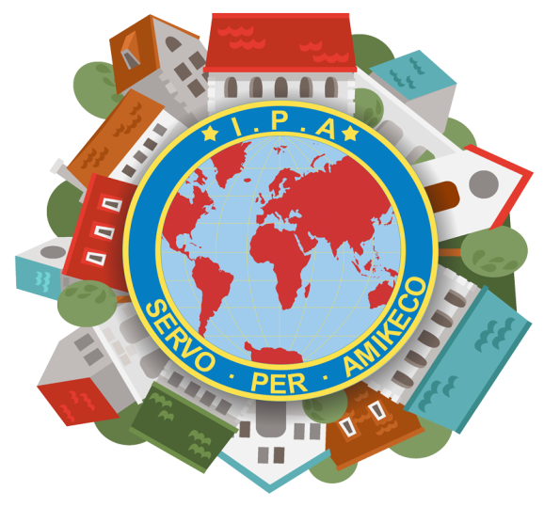
The Socio-Cultural Committee of the IPA is at present in the process of compiling all of these into an easy-to-use reference guide, and making it available to all IPA members on the International Website, as well as in the IPA Hosting Book.
Although there are already many such facilities available internationally, it is our objective to grow the numbers.
The only condition is that the owners/management of such facilities provide accommodation to paid-up members of the IPA at a discounted rate.
There is no cost for the owners/management to have such a facility registered as ‘Other IPA Accommodation’.
The IPA in turn commits itself to market such facilities as ‘Other IPA Accommodation’ on its Website, in Newsletters and other forms of communication to members – locally, within sections as well as internationally.
Many of our IPA members already have access to such facilities and probably know the owners and management thereof.
It is with this in mind that we call on our members to support this drive, and if you come across any facility where the owners/management are willing to provide accommodation to our members, please forward this information to your Section, so that we can register the information on our Website and in our IPA Hosting Book.
Thank you for your assistance!
H. (Vossie) Vos, member of the Socio-Cultural Commission

Consortium for Streetchildren Research Conference 2016

Is it time for rights-based change or changing rights?
Is there a need for legal, social and practical strategies for street-connected children? These questions formed the core topic of the Consortium for Street Children’s (CSC) 4th Annual Research Conference, which took place in London on 3 November 2016.
After an introduction by Lorraine van Blerk, University of Dundee and Chair of the CSC Research Expert Forum, and a welcome by Sarah Thomas de Benitez, CEO of CSC, two panel discussions on children’s rights and strategies followed.
In addition, the research conference had three workshops: In the first one participants were asked what are human rights – what do we need to know – what do we need to show – what research do we want? This workshop was for practitioners and fundraisers to discuss what research they favour in an era of rapid change, and it explored the different needs that drive research projects and determined ways to pin-down exactly what those needs are.
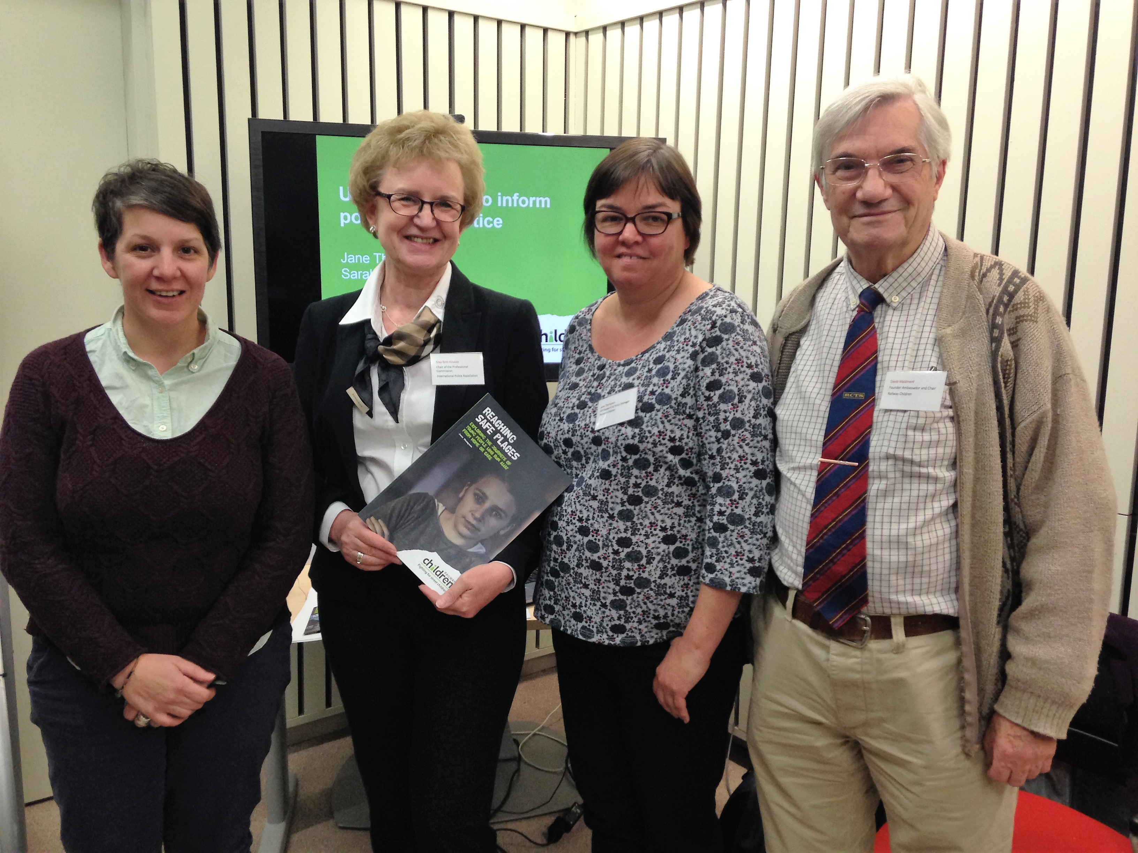
The international children’s charity ‘Railway Children’ presented using research to improve policy and practice in an international NGO. This second workshop explored different research methods and approaches taken by the organisation to improve their policy and practice, and discuss the strengths and challenges associated with each. The Railway Children charity www.railwaychildren.org.uk works with street children in India, Africa and the UK and has helped 270 000 children over the past 20 years. It focusses on children who run away or are forced to leave homes where they suffer poverty, violence, abuse and neglect.
The third workshop was entitled ‘Resilience: bridging the gap between research and practice’. This workshop explored the relevance of findings from a three-country study on children’s resilience to sexual abuse or exploitation (the Bamboo Initiative) http://oakfnd.org/childabuse to the experiences of street-connected children. It also looked at how to bridge the gap between research on resilience and resilience in practice.
CSC conferences feature high-quality presentations and research. The IPA is a welcomed and appreciated NGO, and our contribution is recognised. In many countries around the world, the Police lack knowledge regarding the rights and needs of street-connected children, and they are not given any tools by their governments to support the children or transfer them to social security. The IPA’s presence in 100 countries therefore ensures that the street-connected children’s’ voices will be heard and acknowledged.
May-Britt Rinaldo, Chair of the Professional Commission
IPA HOUSES – YOURS TO DISCOVER!

IPA House, AltesRathaus, Walluf, Germany

The IPA House‘AltesRathaus’ is situated in the town of Walluf and only 15 minutes away from Wiesbaden, Mainz and the tourist attraction ofRüdesheim on the River Rhine.
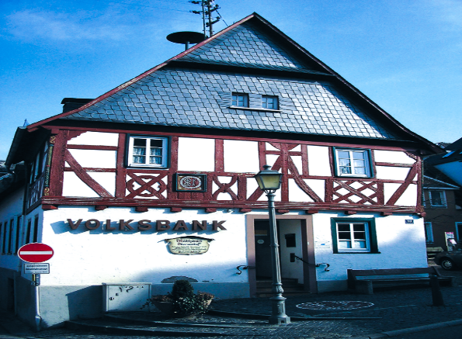
The IPA House – ‘The Old Town Hall’, renovated in 1993, was built in 1412 as a half-timbered house and served as the town hall until 1972.
Today you’ll find a branch bank of the ‘WiesbadenerVolksbank’ on the ground floor.
The IPA facility, which accommodates 5 people, is situated on the upper floor and has two bedrooms - bedroom 1 has a double bed with an additional bed, and bedroom 2 has 2 single beds. A cot is available on request.
In addition, there are two toilets, a bathroom, as well as a large living room with a television.
Oberwalluf - called Walluf, is known as the ‘gateway to the Rheingau’, and is located next to the city of Wiesbaden and the town Eltville. The historic centre of Eltville is famous for sparkling wine and roses, as well as for its castles and scenic lanes.The inventor of the printing press, Johannes Gutenberg, is highlighted in a museum close-by.
Other local attractions include the Rheingau, the Taunus mountains and the Golden City of Mainz, founded by the Romans two thousand years ago!
There are good public transport links available to all cities in the vicinity, and the airports of Frankfurt-Hahn and Frankfurt-Rhein-Main are nearby.
Contact Details & Bookings:
- House Manager: Knut Schneider
- Address: Marktstrasse 18, 65396 Walluf-Oberwalluf
- Reservations: Knut Schneider
- Tel: +49 (0) 1717621958
- Mobile: +49 (0) 6722 6003
- Email: vorstand@ipa-rheingau.de
- Website: www.ipa-rheingau.de and http://www.ipa-deutschland.de
- Prices: Accommodation costs: € 20 (1 x night), €15 for 2 or 3
nights per adult per night, and for longer bookings € 12.

Compiled as per information received from Hubert Vitt, IPA Germany

IPA Apartment, Thessaloniki, Greece

The IPA Facility is a 6th floor apartment situated in Thessaloniki, some 250 metres from the Central Police Building and has been in operation since 1997.
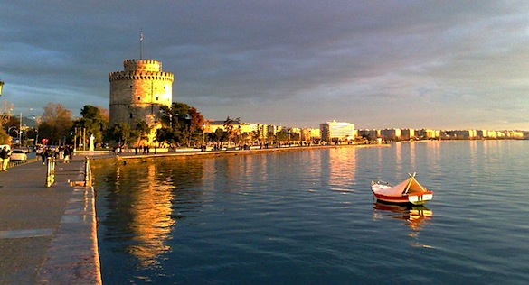
Thessaloniki is the second-largest city in Greece and the capital of Greek Macedonia, It is nicknamed the ‘co-capital’, as it acted as the ‘co-reigning’ city of the Eastern Roman (Byzantine) Empire, alongside Constantinople.

The Greek port city on the Thermaic Gulf of the Aegean Sea saw much of its centre destroyed in the Great Fire of 1917. The rebuilt 20th-century city has a modern European layout, and is a hub for international trade and culture.
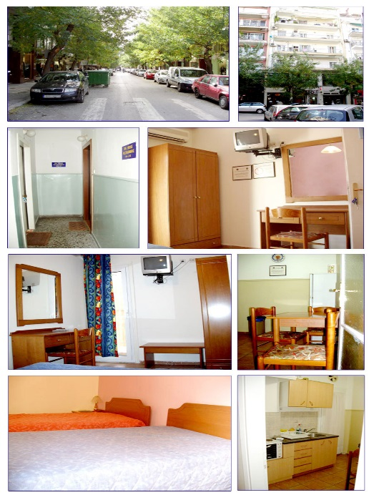
Theapartmenthas 4 double rooms with air conditioning, TV, as well as blankets, sheets, pillows and towels. There is a shared bathroom and second WC.
The facility has a kitchen with a refrigerator and all necessary utensils.
There is free Wi-Fi.
The apartment is close to the centre of the city, near public transportation, and is therefore ideal for sightseeing in the city: the White Tower, the Royal Theatre, the International Exhibition Centre, as well as archaeological sites and Byzantine monuments, museums and the city harbour.
No pets allowed.
Accommodation at the Facility cannot be extended beyond 15 days (except forspecial reasons).
Contact Details & Bookings:
- House Manager: ChristodoulosChristodoulis
- Address: 28 Sigrou Street, 6th Floor, 54630, Thessaloniki
- Reservations: ChristodoulosChristodoulis
- Tel: +306975909909
- Email: chistoschris@gmail.com
- Website: http://www.ipa-gr.org
- Prices 2016: 15 € per person per night

Kyriakos KARKALIS, International Relations, IPA Greece

LAST WORD

IPA membership is what you make of it …
Earlier this month, I dealt with a request from Sweden: an IPA member had applied for a position where French was required, and she was now interested in getting into contact with French IPA members to prepare for this.
A few email exchanges with IPA France, IPA Sweden and the Swedish member later, I received a short happy email back, explaining that she had now more French contacts than she could ever have imagined!
Shows me two things, really:
Firstly, despite the IPA being a large organisation with a fair bit of bureaucracy attached to it, requests of any type can nevertheless be sorted quickly and satisfactorily. Nice to see ☺
Secondly, membership is what you make of it. This request illustrated to me that IPA can be so much more than receiving your membership card, and discovering a list of events or invitations in your email or on your social media. Taking the initiative to ask for IPA contacts to improve language skills might not only open the door to new friendships, but could also save this member a bit of money: no need to go to expensive language classes for her!
Seems to me that it is the same as in any other walk of life:
The more you put into your IPA membership, the more you get out of it.
Elke

CALENDAR OF EVENTS

Please find below a list of IPA events for the next 12 months:

Section | Date | Event
Poland | 8-11 Feb 2017 | VIII Int. uniform int’l football tourn., Warsaw
Macau | 18 Feb 2017 | Launch of Asian Affairs Bureau
Germany | 22-28 Feb 2017 | 50th Carnival of IPA Cologne
Finland | 28 Feb-4 Mar 2017 | IEB Meeting, Äkäslompolo
New Zealand | 11 Mar 2017 | Social Lawn Bowls Competition, Tauranga
Croatia | 31 Mar-1 Apr 2017 | Conference ‘Security of historical cities’, Split
Austria | 20-23 Apr 2017 | XIX National Congress, Pörtschach
Croatia | 29 Apr-13 May 2017 | IPA Dubrovnik Friendship Weeks 2017
Croatia | 6 May 2017 | Precise Shooting Tournament, Stobreč
France | 12-15 May 2017 | Motorcycle Rally, Perpignan
Spain | 12-21 May 2017 | CANCELLED - Barcelona Supermotor Event
Romania | 18-21 May 2017 | Meeting of Central and Eastern European Sections, Bucharest
Canada | 21-28 May 2017 | Cruise to Bermuda+ Tour of New York
Germany | 23-27 May 2017 | IEB Meeting, Gimborn
Spain | 25-28 May 2017 | XIV 7-a-side int’l football champ., Tarragona
Spain | 28 May-3 Jun 2017 | Barcelona Golf and Leisure Week
Estonia | 2-4 Jun 2017 | Nordic Baltic Meeting
USA | 11-16 Jun 2017 | Young Police Officers’ Seminar, Green Bay
Czech Rep. | 11-17 Jun 2017 | Prague Friendship Week
Italy | 15-15 Jun 2017 | 7th IPA Motorcycle Rally, Dolomites
USA | 19-28 Jun 2017 | Pacific Northwest Tour
Russia | 22-25 Jun 2017 | Northern European Forum, St. Petersburg
Estonia | 14-16 Jul 2017 | IPA Estonian Summer Days
South Africa | 29 Jul-13 Aug 2017 | International Youth Gathering
Germany | 11-13 Aug 2017 | 1st Int. Motorcycle Gathering, Hamburg
Bulgaria | 19-24 Sep 2017  24 Sep-1 Oct 2017 | 62nd IPA World Congress, Albena  Friendship Week
USA | 1-6 Oct 2017  6-10 Oct 2017 | NDC Meeting, Charleston  Friendship Tour Charleston and Savannah
Netherlands | 9-13 Oct 2017 | 35th WPIST, Eibergen, GroenloandLichtenvoorde

FORTHCOMING GIMBORN SEMINARS

Please see below a 4-month summary of seminars with vacancies, offered by our international education centre IBZ Gimborn in Germany.
If you are interested in taking part in any of these seminars, please follow the link:

www.ibz-gimborn.de

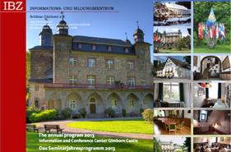

Date | Seminar | Language
13-17 Feb 2017 | Gewalt im Spiel – Ultras und Hooligans im Umfeld von Fußballspielen | G
20-27 Feb 2017 | Islamistischer Terrorismus – Europa im Fadenkreuz religiöser Fanatiker | G
27 Feb-03 Mar 2017 | Berufsentwicklung – Alles ist erreichbar – auch für Frauen bei der Polizei | G
06-12 Mar 2017 | Fasten? Trau Dich! Heilfasten im Oberberg. Land | G
06-10 Mar 2017 | Ethik unter Druck – Werteorientiertes Handeln auf dem Prüfstein | G
13-15 Mar 2017 | Zeitalter der Populisten | G
17-19 Mar 2017 | Qualifizierte Vernehmungen im Bereich der Schwer- und Bandenkriminalität | G
27-29 Mar 2017 | Die Macht der Bilder oder Bilder an die Macht | G
03-05 Apr 2017 | Führung in Aussicht / den Rollenwechsel meistern | G
05-07 Apr 2017 | Wut im Bauch?! Möglichkeiten im Umgang mit schwierigen Kindern und Jugendlichen | G
18-22 Apr 2017 | ASP Instructor Course | E
24-28 Apr 2017 | La contrefaçon – Une menace sous-estimée ? | F
08-12 May 2017 | Social Media Management für Polizei, Justiz und Öffentliche Verwaltung | G
08-10 May 2017 | Europa in der Krise – Herausforderungen in der Flüchtlingskrise // Europa in crisis – uitdagingen in de vluchetlingencrisis | G and D
22-24 May 2017 | Zeitalter der Populisten | G
29 May-02 Jun 2017 | Cybercrime – Kampf gegen die Bedrohung aus dem Cypercrime | G

